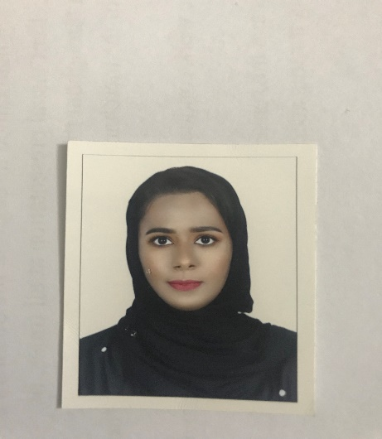**Curriculum Vitae**

**Sajida Noor Mohamed**

Blodg 1596 Flat 1 Road 625 Block 306

Manama Town, Bahrain.

Mob: **66927720**

Sales Assistant

PERSONAL SUMMARY

An articulate, smart and professional sales assistant who always puts the customer first. Possessing an ability to identify a customer’s needs promptly and accurately, Michael has a long history of being able to satisfy the most demanding of shoppers. He possesses a track record of meeting sales targets by any means at his disposal, including conducting sales focused research and surveys with customers and launching promotions through a company’s website. He is career minded and is currently looking for a unique opportunity to join a company that offers long term

**Personal Information:**

***Name:*** Sajida Noor Mohamed

***Date of Birth:*** Nov 2, 1992

***Place of Birth:*** Manama, Bahrain

***Gender:*** Female

***Marital Status:*** Single

***Qualification:*** graduated from Al Hoora Secondary Girls School

***Email Address:*** [sajidanoor797@gmail.com](mailto:sajidanoor797@gmail.com) – [sajidaahmed716@gmail.com](mailto:sajidaahmed716@gmail.com)

***Contact No:*** 66927720

**Professional Abilities:**

***Personal and Self Management:***

* Strong personal initiative; quick learner in mastering job requirements.
* Highly organized and dedicated with positive attitude.
* Ability to learn very fast from mistakes, and not to be repeated.
* Excellent written and oral interpersonal communication skills.
* Perform multiple assignments under pressure and consistently meet deadlines.
* Hard worker; committed to efficient and productive operations.
* Friendly, best at team work.

***Achievements & Hobbies:***

* Interested in discovering new and challenging things, surfing net.
* Photography
* Travelling and surfing the internet
* Internet wide knowledge background for learning something new and entertainment
* Character Certificate After schooling (2015)

**employment history**

Responsible for not only assisting the customer with the selection of products, but also involved in the day to day running of the store in areas such as processing payments, meeting sales targets and the maintaining stock levels. Involved in any area that may benefit the store, sales team and customers.

**Duties**

**Retail Company forever21 SALES ASSISTANT 9-feb-2017 / 30-7-2018 – Present**

• Processing new stock and getting it ready to be put out on display.

• Arrange orders and deliveries of stock for customers.

• Helping out in the fitting rooms.

• Keeping an look out for shop lifters, fraudulent credit cards and malicious damage to stock.

• Standing at the front of the shop and talking to passers by about the stores special offers.

• Taking the clothes people leave at the fitting rooms back into the shop as quickly as possible, so that other customers can see them.

Loreal Paris SALE ASSISTANT 2-april-2019 / 2-july-2019 As a part-time

**Position Description**  
A beauty advisor analyzes a customer’s skin, offers skin care advice and sells cosmetics and beauty products to the customer.

**Duties and Responsibilities of a Beauty**

•Reads and understands information about new products being developed and emerging on the market.  
•Attends workshops and seminars on new product lines.  
•Identifies skin types and skin conditions and knows the best products for each one.  
•Gives product demonstrations for customers.  
•Performs makeovers on customers.  
•Answers customers’ questions and makes nervous customers feel comfortable and relaxed.  
•Helps customers find the products that best suit their skin and hair types.  
•Sells customers as many appropriate products as possible.  
•Asks customers about any skin allergies and makes them aware of any products they should avoid.

**Computer Skills:**

* Software & Hardware.
* Microsoft Office.

**Languages Known:**

* English - Written & Spoken
* Arabic - Written & Spoken

**Job Experience:**

* Worked as a sale person in Loreal Paris -Juffair mall - 2-april-2019 / 2-july-2019 As a part-time
* Worked as a Sale Person in FOREVER21 – City Center Kingdom of Bahrain from Feb-2017- July-2018
* Worked as cashier in Shadow Palace Salon in Saar, Kingdom of Bahrain for 8 Months (2015)
* Worked as cashier in Supermarket, Kingdom of Bahrain for 1 year (2014)

**Reference**: Available upon request

available to you throughout the application process

**I HEREBY CERTIFY THAT THE ABOVE INFORMATION IS TRUE AND CORRECT TO THE BEST OF MY KNOWLEDGE.**